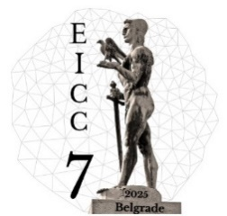
RESERVATION FORM
7th EuChemS Inorganic Chemistry Conference
September 7-11, 2025

Please complete the required form & return BACK by e-mail.
E-mail: reservations@hotelmuseum.rs
LAST NAME: | FIRST NAME:
ADDRESS: | POSTAL CODE:
E-MAIL: | PHONE:
ACCOMMODATION INFORMATION
ARRIVAL DATE: | DEPARTURE DATE:
ARRIVAL TIME: | DEPARTURE TIME:
⊲ Superior double / twin room  ⊲ Superior double / twin room (museum view)  Surcharge for double use is 7€ per person / per day. | 130€ (single use)  135€ (single use)  The price is per room, per day.  The given price does not include the city tax and the insurance in which the total amount is 180 RSD per person per day.
PAYMENT AND CANCELLATION TERMS
1. As a guarantee for your reservation, we require your credit card number along with the expiration date. All reservations are subject to request and availability.
2. Final settlement upon arrival from the hotel.
Cancellation Policy:
- Cancellations made within 6 days prior to the arrival date will result in a charge equal to the first night’s stay.
- In the case of a no-show, 100% of the reservation value will be charged.
- Please note that in case of any change or cancellation will be valid only in written.

Reservation must be completed up to 25.07.25.

Transfer: Airport – Hotel (one way) EUR 45
Transfer: YES NO | Arrival time (flight number):
I authorize you to debit my credit card for the above accommodation expenses.
CREDIT CARD INFO:
Cardholder Name:

Card No: |  | Card expiry date:
Signature: |  | Date:

